California Case

***As of December 2014, California not only has more plug-in electric vehicles than any other American state but also more than any other country in the world.***

“*The fleet of plug-in electric vehicles in the United States is the largest in the world, with a 43% share of global sales as of September 2014*.” [1] And with 40% of all EVs sales in U.S., California State is counted biggest market around the globe. When considered from this point of view, California can deliver us great amount of valuable information about EVs and EVs charging station market.

# Market

With 23% of Volt sales California is the leading Volt market during the second quarter of 2012. The leading regional markets in California State were San Francisco, Los Angeles, and San Diego.[2] In addition with 50% of its total sales Tesla Model S.6, Tesla Motors reported that in March 2013 California is the largest American market as delivery of 30,000 in the U.S.

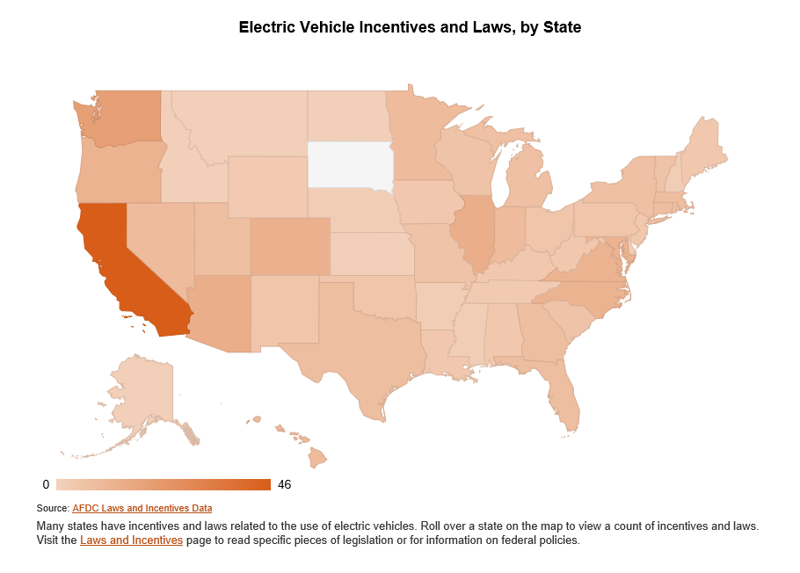

With regard to goal of 1.5 million zero-emission vehicles (ZEVs) in California by 2025, pointed out by Governor of California, Jerry Brown California seems eager for a sustainable energy market.[3]

# Charging stations

The market situation is not just a pushing factor for EVs charging infrastructure but also result of strong infrastructure. These two develop by interlink to each other. “As of March 2013, the United States had 5,678 [charging stations](http://en.wikipedia.org/wiki/Charging_station) across the country, led by [California](http://en.wikipedia.org/wiki/California) with 1,207 stations (21.3%). As for retailers, Walgreens is by far the plug-in friendliest, with 365 stores deploying plug-in stations nationally. 55 Kohl's stores had public stations as of March 22, while Whole Foods was home to 39 stations.”[4]

***[In terms of public charging points, there were 19,472 public outlets available across the country by the end of December 2013, again led by California with 5,176 (26.6%) public charging points.]***

# Incentives

California has been leader in the promotion of EVs as the state has several financial and non-financial incentives in place. In addition to the existing tax incentives, EVs are promoted with the Clean Vehicle Rebate Project (CVRP). [5]

Clean air stickers that allows the vehicle with a single occupant in high-occupancy vehicle lanes (HOV)[6] can be used in EVs. With regard to 59% of EVs buyers define it is extremely or very important motivator, California’s incentives covers many aspects.

The California Air Resources Board (CARB) was mandated by a package of law signed by Governor Brown to provide extra credit for low income residents who want to buy EVs. They will also assist in the installation of charging stations in apartment buildings in which only 4% of EVs users live.[7] Even though, Clean Vehicle Rebate Project does not cover all EVs sold in California because not every EV owner applies for the rebate, as of 10 March 2014, a total of 52,264 clean vehicle rebates have been issued, for a total of US$110,222,866 disbursed, with only US$3.8 million remaining for fiscal year 2013-2014.[8]

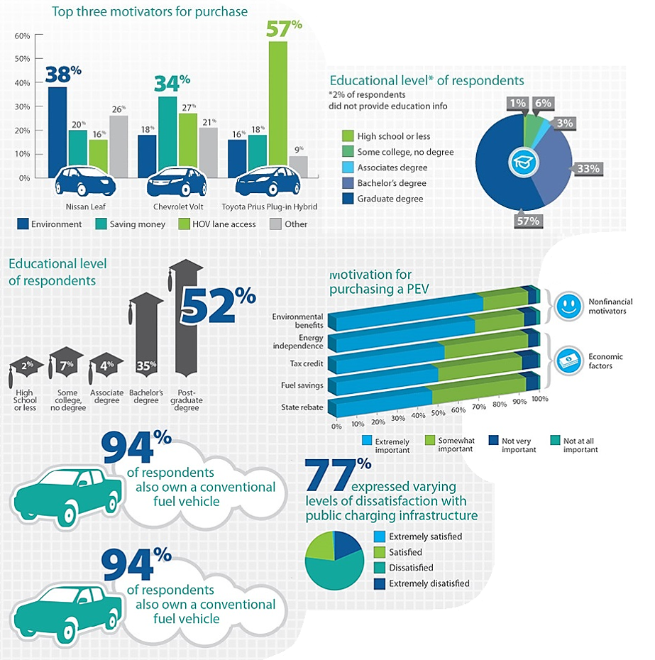

# Customers (Survey Report)

Center for Sustainable Energy's (CSE) manages long term collaborative EVs owner surveys for last few years and provides significant data for all market related companies.

**Highlights from the survey include:** [9]**-**[10]

* *Chevy Volt-driving respondents are more than four times as likely to have a level 2 charging station installed at their home than Toyota Prius Plug-In respondents.*
* *Workplace charging availability is becoming more widespread, 46% of respondents reported access to workplace charging, an increase of 14% from March 2012.*
* *Of those with access to workplace charging, 74% have access to this charging at no cost to the driver, down from 89% in March 2012.*
* *Though low, driver satisfaction with public charging infrastructure continues to improve, rising from 17% in March 2012 to 29% in May 2013.*
* *The CVRP rebate was as an important motivating factor in the purchase decision for 95% of respondents.*
* *For occasional public charging outside the home, two-thirds of respondents reported a willingness to pay up to $1.00 per hour with less than one-third willing to pay $1.50 per hour.*
* *For daily charging outside the home, only 16% of respondents expressed a willingness to pay up to $1.25 per hour, but 43% were willing to pay $1.00.*

# Problems & Solutions

California EVs market has not been smooth, however, the fact that EVs sales dip in the second half of 2014. As decreasing price of gasoline cars for some reasons, it is expected that trend of EVs sales worsen in 2015 not just in California but all around the U.S. Tam Hunt[11], listed out some important points to solve this problem. Significance of these points can be referenced as methods to develop EVs market around the globe.

*1. Expedite approval of utility applications to build out the EV charging infrastructure rapidly*

*2. Dramatically expand education and outreach efforts by working with nonprofit educational organizations*

*3. Create a tariff that allows EV owners to earn money by absorbing excess solar power during peak production times*

*4. Improve the state rebate process*

*5. Increase the state gas tax and funnel receipts back into rebates for EVs*

“At this time, with EV sales dipping dangerously, it is needed to consider all the options for getting sales back on track.” Says Tam Hunt

1. Dana Hull (2014-09-08). ["California charges ahead with electric vehicles"](http://www.mercurynews.com/business/ci_26493736/california-charges-ahead-electric-vehicles). [*San Jose Mercury News*](http://en.wikipedia.org/wiki/San_Jose_Mercury_News). Retrieved 2015-03-15
2. Nathan Bomey (2012-06-05). ["California can't get enough of the Chevy Volt as sales surge"](http://www.freep.com/article/20120605/BUSINESS01/206050424/California-can-t-get-enough-of-the-Volt-as-sales-surge). [*Detroit Free Press*](http://en.wikipedia.org/wiki/Detroit_Free_Press). Retrieved2012-06-06.
3. Staff (2012-03-23). ["Governor Brown Announces $120 Million Settlement To Fund Electric Car Charging Stations Across California"](http://gov.ca.gov/news.php?id=17463). Office of Governor Edmund G. Brown Jr. Retrieved2014-09-22
4. [U.S. Department of Energy](http://en.wikipedia.org/wiki/U.S._Department_of_Energy) (2013-12-25). ["Alternative Fueling Station Counts by State"](http://www.afdc.energy.gov/fuels/stations_counts.html). Alternative Fuels Data Center (AFDC). Retrieved 2013-12-31. *The AFDC counts electric charging units or points, or EVSE, as one for each outlet available, and does not include residential electric charging infrastructure*.
5. ["Clean Vehicle Rebate Project FAQ: Changes in CVRP FY 2011-2012"](https://energycenter.org/index.php/incentive-programs/clean-vehicle-rebate-project/frequently-asked-questions-cvrp#changes). Center for Sustainable Energy California. Retrieved2011-05-22.
6. [California Department of Motor Vehicles](http://en.wikipedia.org/wiki/California_Department_of_Motor_Vehicles) (March 2014). ["Clean Air Vehicle (CAV) Decals - High Occupancy Vehicle HOV Lane Usage"](http://www.dmv.ca.gov/vr/decal.htm). DMV California. Retrieved 2014-03-23.
7. Melanie Mason and Patrick McGreevy (2014-09-21). ["Gov. Jerry Brown signs bills to boost purchases of electric cars"](http://www.latimes.com/local/political/la-me-pc-brown-electric-vehicles-20140921-story.html). [*Los Angeles Times*](http://en.wikipedia.org/wiki/Los_Angeles_Times). Retrieved 2014-09-21.
8. [Clean Vehicle Rebate Project](http://en.wikipedia.org/wiki/Clean_Vehicle_Rebate_Project) (2014-03-10). ["Clean Vehicle Rebate Project Statistics"](http://energycenter.org/clean-vehicle-rebate-project/cvrp-project-statistics). California Center for Sustainable Energy. Retrieved 2014-03-23.
9. <http://energycenter.org/clean-vehicle-rebate-project/vehicle-owner-survey/feb-2014-survey>
10. http://energycenter.org/clean-vehicle-rebate-project/vehicle-owner-survey/may-2013-survey
11. <http://www.greentechmedia.com/articles/read/how-california-can-get-electric-vehicle-adoption-back-on-track>